**Part:1 Find the culprits and nail them-debugging scripts.**

**1. Find the culprit.**

**Solution:** In the above code in the “alert” message there is only given single codes instead of double codes at the end.

<!DOCTYPE html>

<html>

<body>

<script>

alert( "I’m JavaScript!");

</script>

Whats the error in this ?

</body>

</html>

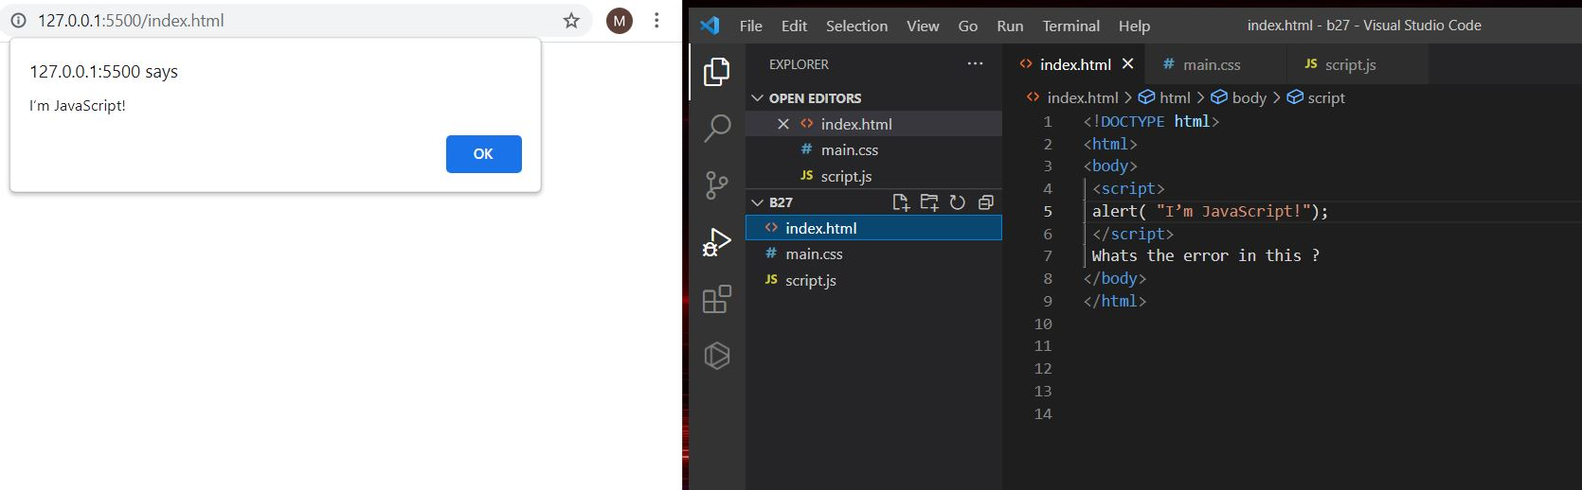

**2. Find the culprit and invoke the alert.**

**Solution:**

**Fix.html**

<!DOCTYPE html>

<html>

<body>

<script src="script.js"></script>

</body>

</html>

**Script.js**

alert("I'm invoked!");

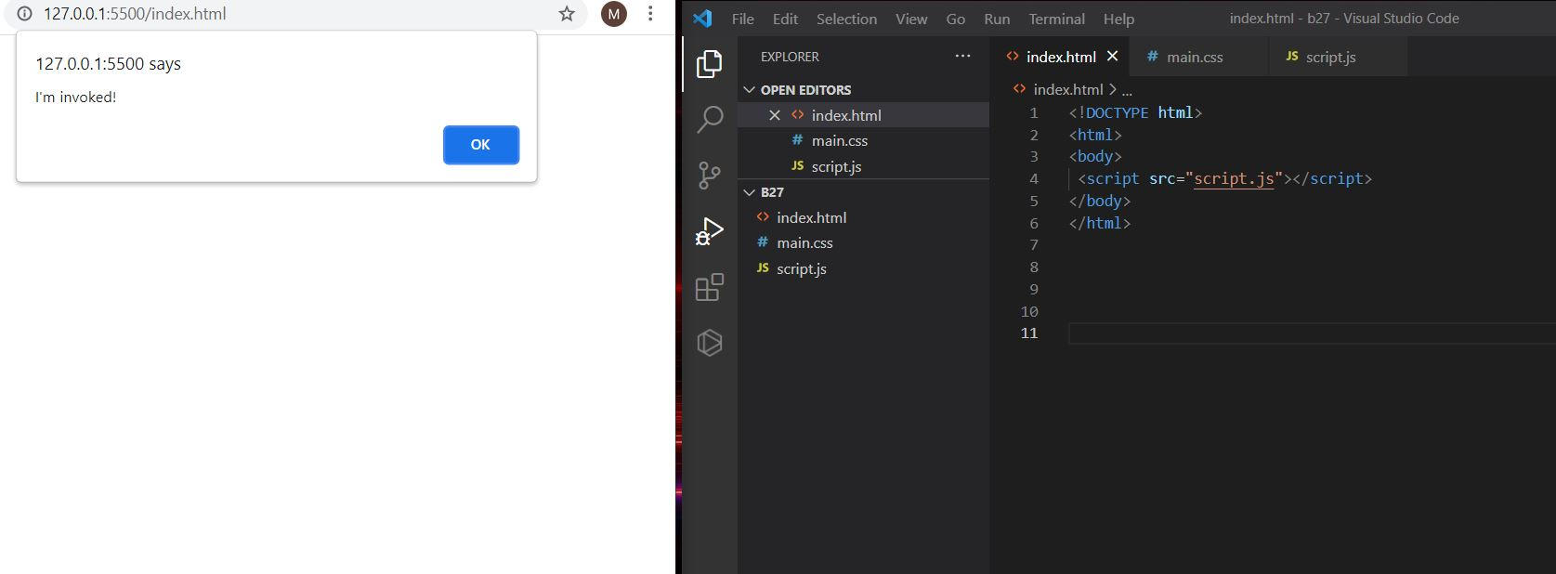

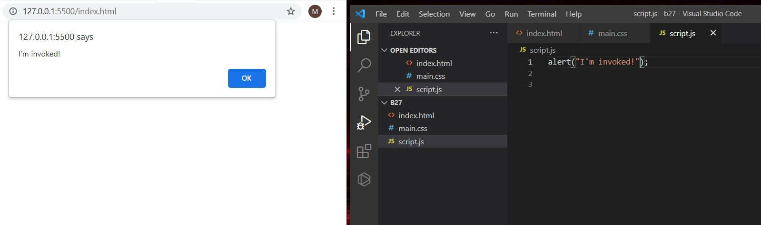

**3. Explain the below how it works.**

**Solution:**

**explain.html**

<!DOCTYPE html>

<html>

<body>

<script src="script.js"></script>

</body>

</html>

**Script.js**

alert("I'm JavaScript!");

alert('Hello') // this line is not having semicolon

alert(`Wor

ld`)

alert(3 +

1

+ 2); // this is multiple line code and its working

* First after giving the code and run we will get the first alert like “I’m Javascript” after clicking ok next message will appear i.e., ‘Hello’ in next ok (Wor) and a newline in alert message (ld) will appear and after clicking ok 6 will appear as alert.



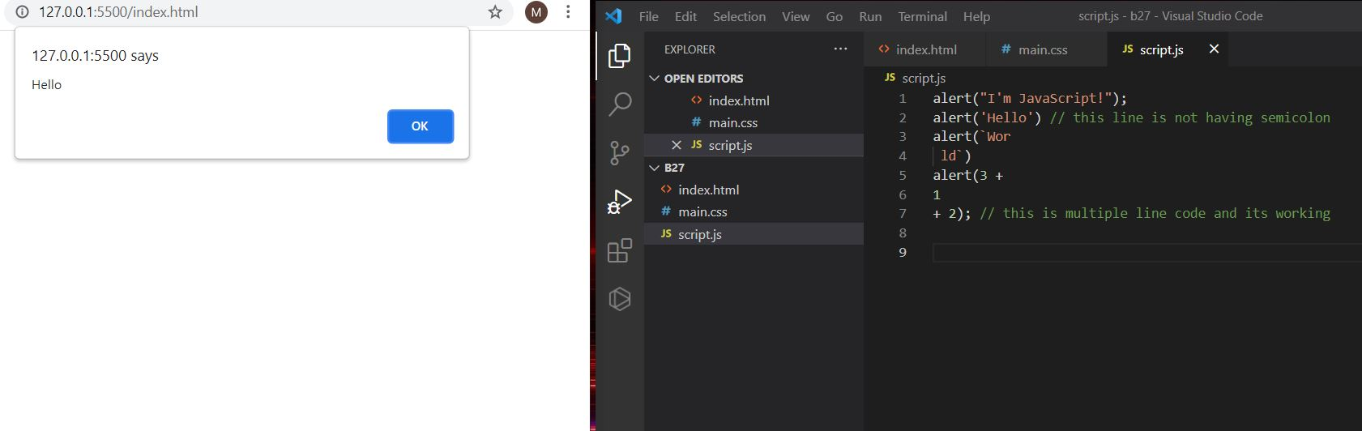

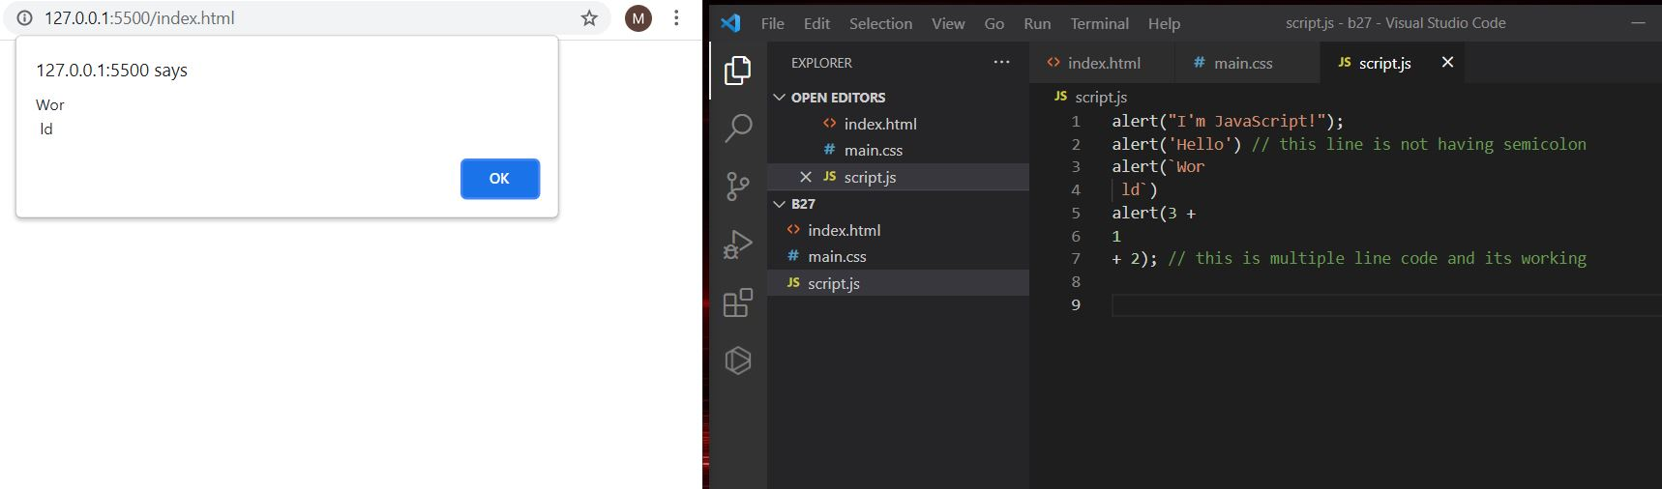

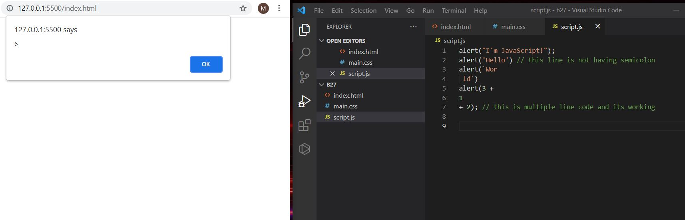

**4.Fix the below code to alert Guvi geek**

**Solution:**

**fix.html**

<!DOCTYPE html>

<html>

<body>

<script src="script.js"></script>

</body>

</html>

**Script.js:**

let admin=9, fname=10.5;

fname = "Guvi";

lname = "geek";

admin = fname +" "+lname;

alert( admin ); // "Guvi geek"

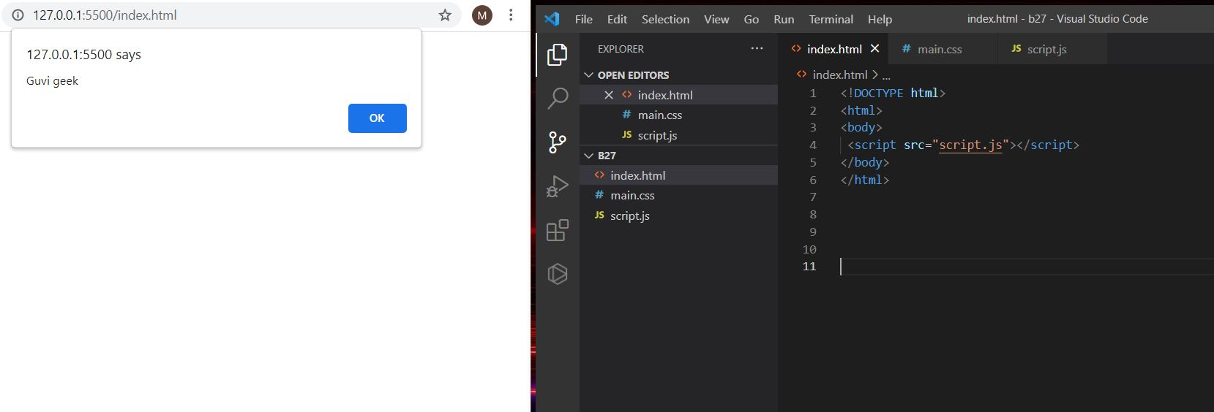

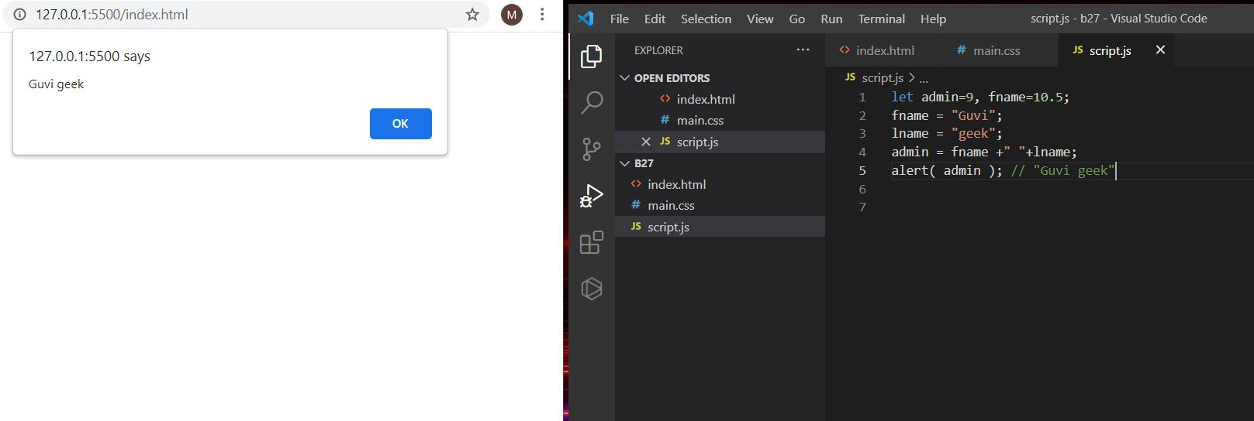

**5. Fix the below to alert hello Guvi geek**

**Solution:**

**fix.html**

<!DOCTYPE html>

<html>

<body>

<script src="script.js"></script>

</body>

</html>

**Script.js:**

let fname=10.5;

fname = "Guvi";

lname = "geek";

let name = fname+" "+lname;

alert( `hello ${name}`);

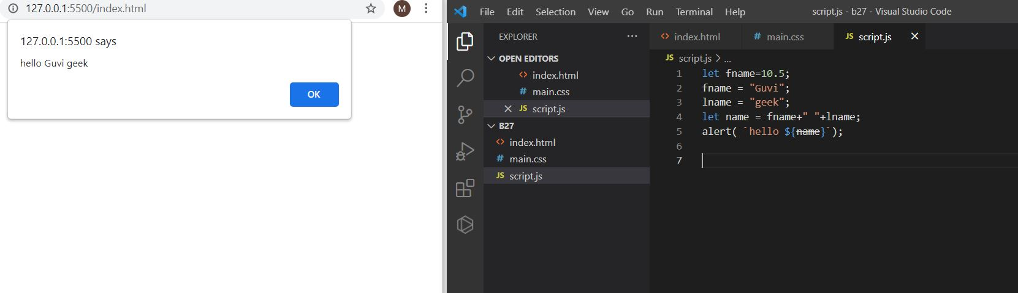

**6,7. Fix the below to alert sum of two numbers**

**Solution:**

**fix.html**

<!DOCTYPE html>

<html>

<body>

<script src="script.js"></script>

</body>

</html>

**Script.js:**

let a = +(prompt("First number?"));

let b = +(prompt("Second number?"));

alert(a + b);

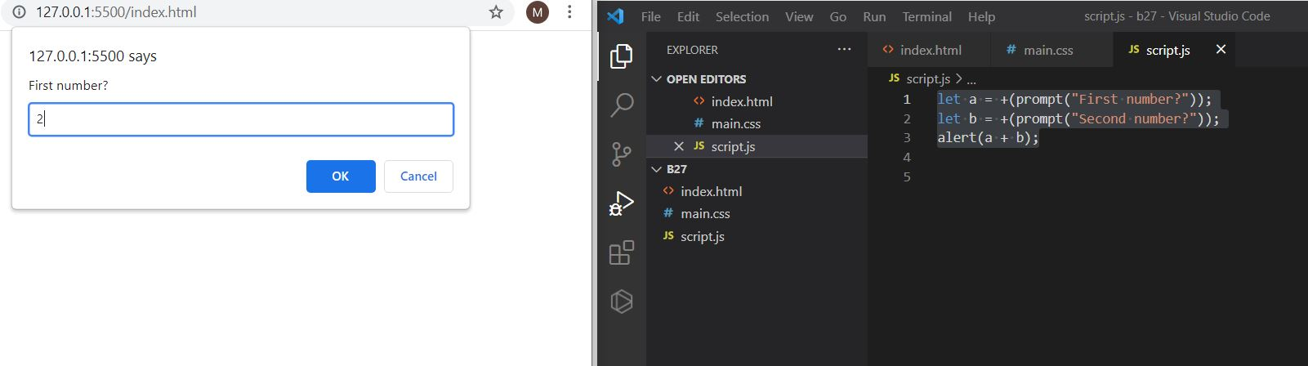

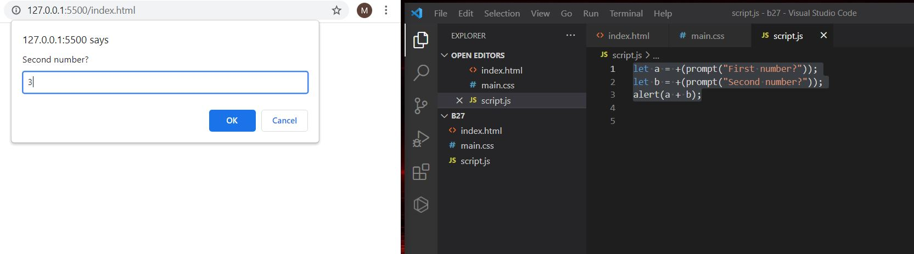

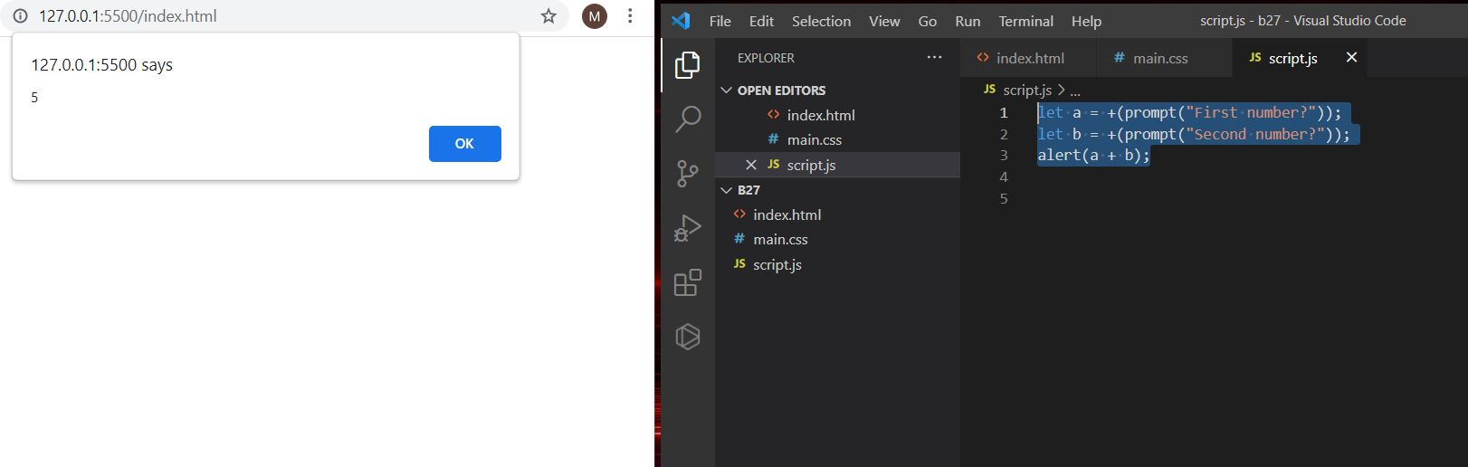

8. **If you run the below script you will get “**Code is Blasted**”**

**Explain Why the Code is blasted and how to diffuse it and get “**Diffused**”.**

**Solution:**

**fix.html**

<!DOCTYPE html>

<html>

<body>

<script src="script.js"></script>

</body>

</html>

**For code blasted:** In this based on the true and the false condition it will get the because we are comparing the strings.

**Script.js:**

var a = "2" > "12";

//Don't touch below this

if (a) {

console.log("Code is Blasted");

}

else

{

console.log("Diffused");

}

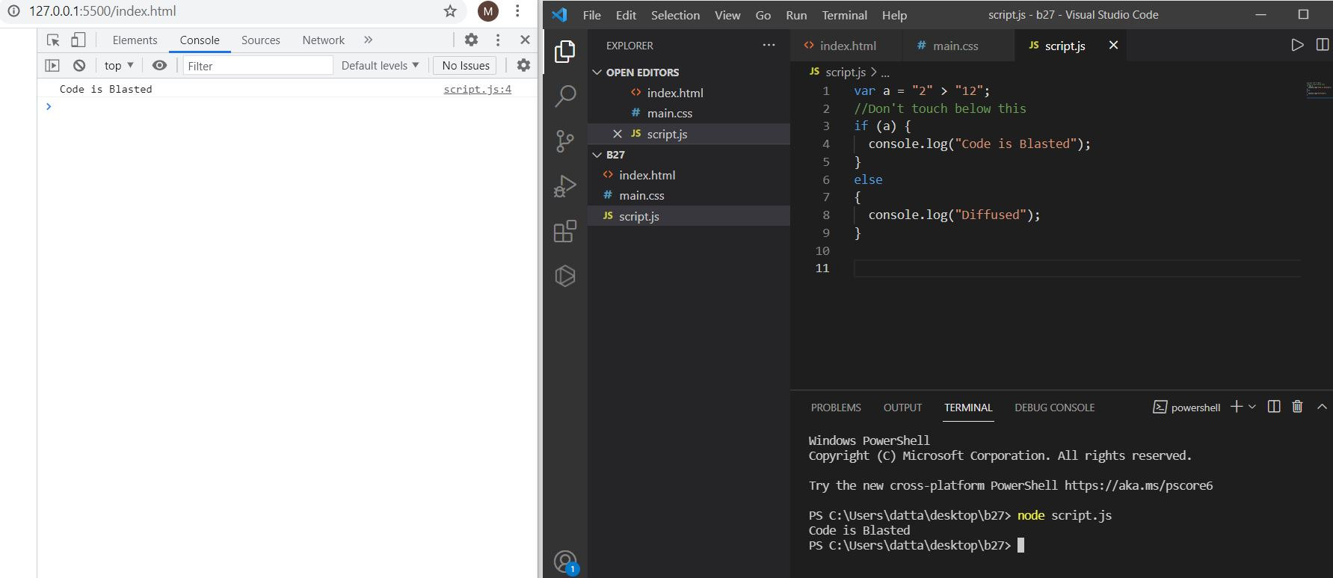

**For diffused:** In this it will check both the data and type if the condition then it will print the diffused.

var a = "2" === "12";

//Don't touch below this

if (a) {

console.log("Code is Blasted");

}

else

{

console.log("Diffused");

}

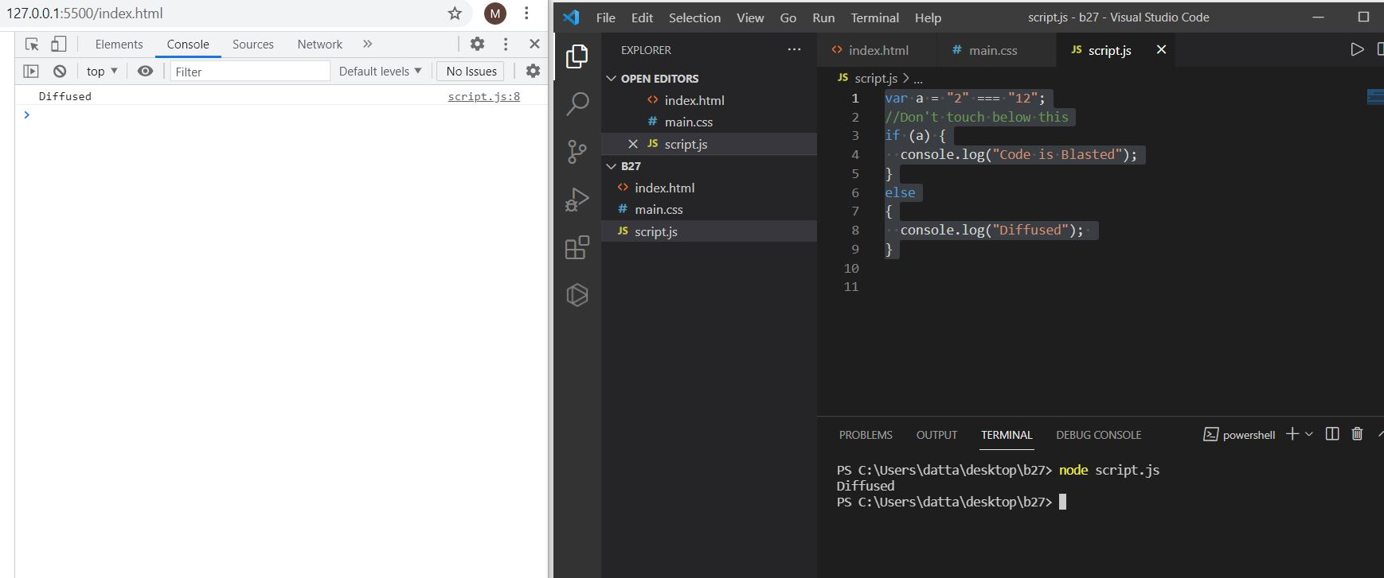

**9.How to get success in the console.**

**Solution:** If we are not given anything in the prompt message it will get success in the console.

**fix.html**

<!DOCTYPE html>

<html>

<body>

<script src="script.js"></script>

</body>

</html>

**Script.js:**

let a = prompt("Enter a number?");

//Don't modify any code below this

if (a) {

console.log( 'OMG it works for any number inc 0' );

}

else

{

console.log( "Success" );

}

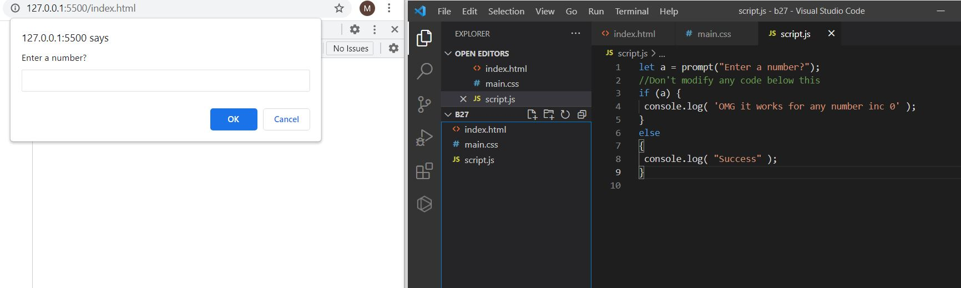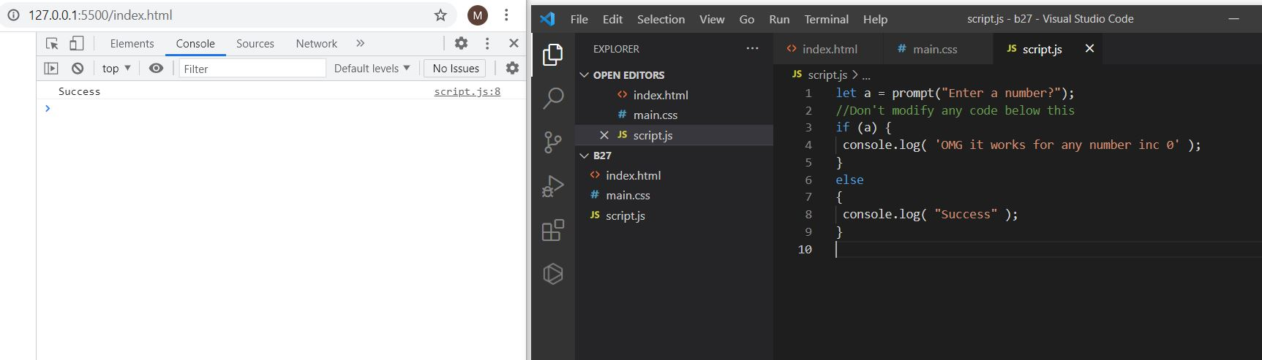

**10. How to get the correct score in the console.**

**Solution: If we give the unary operator + before the prompt and typing the 4 or 6 when the prompt message is revealed it will get those respective messages in the console i.e, correct score if we give another it will show else condition message.**

**fix.html**

<!DOCTYPE html>

<html>

<body>

<script src="script.js"></script>

</body>

</html>

**Script.js:**

let value = +(prompt('How many runs you scored in this ball'));

if (value === 4) {

console.log("You hit a Four");

} else if (value === 6) {

console.log("You hit a Six");

} else {

console.log("I couldn't figure out");

}

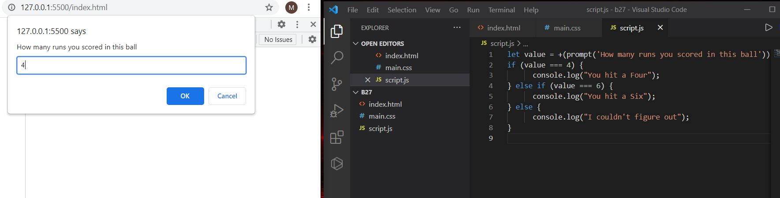

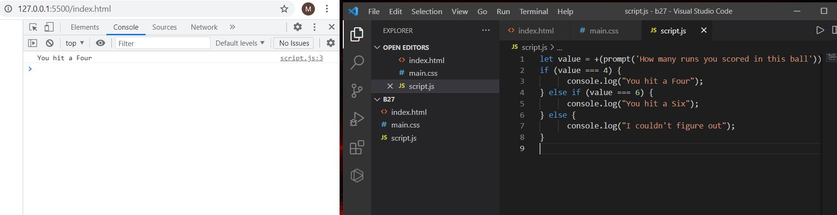

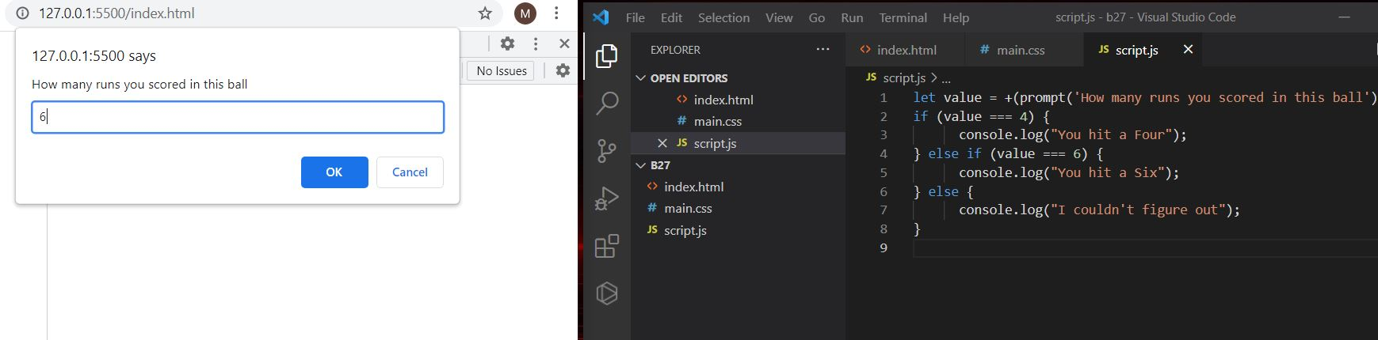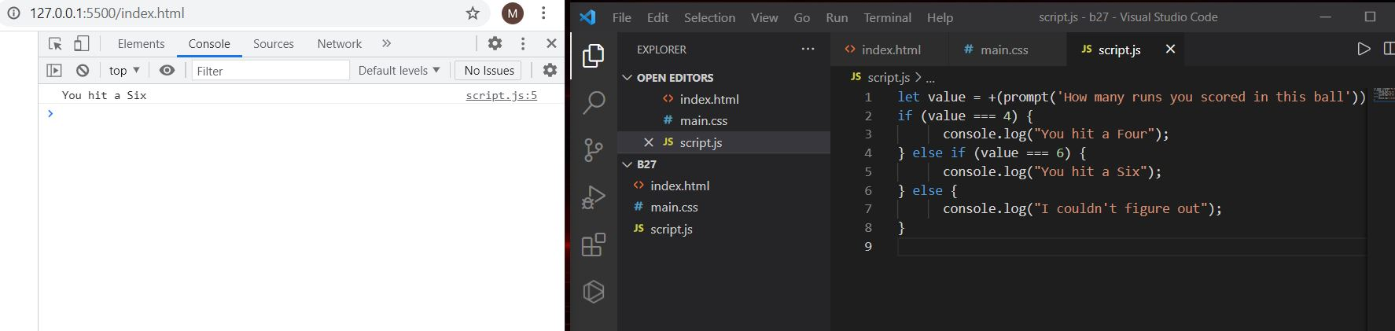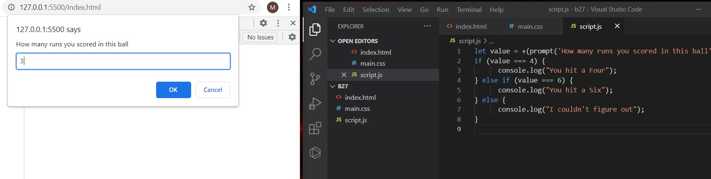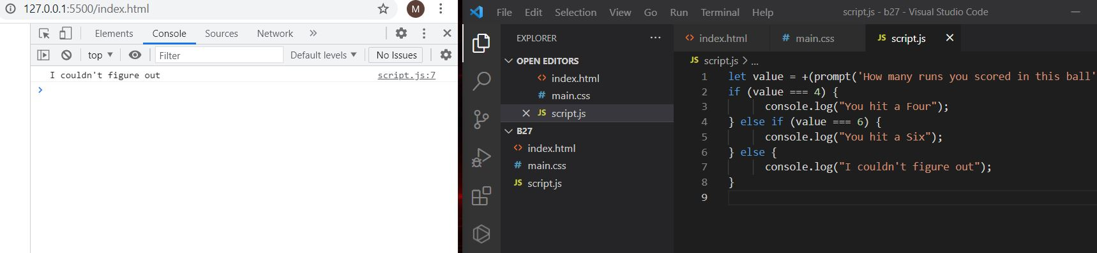

11. **Fix the code to welcome the Employee**

**fix.html**

<!DOCTYPE html>

<html>

<body>

<script src="script.js"></script>

</body>

</html>

**Script.js:**

let login = 'Employee';

let message = (login === 'Employee') ? "Welcome the employee": "nothing";

(login === 'Director') ? 'Greetings' :

(login === '') ? 'No login' :

'';

console.log(message);

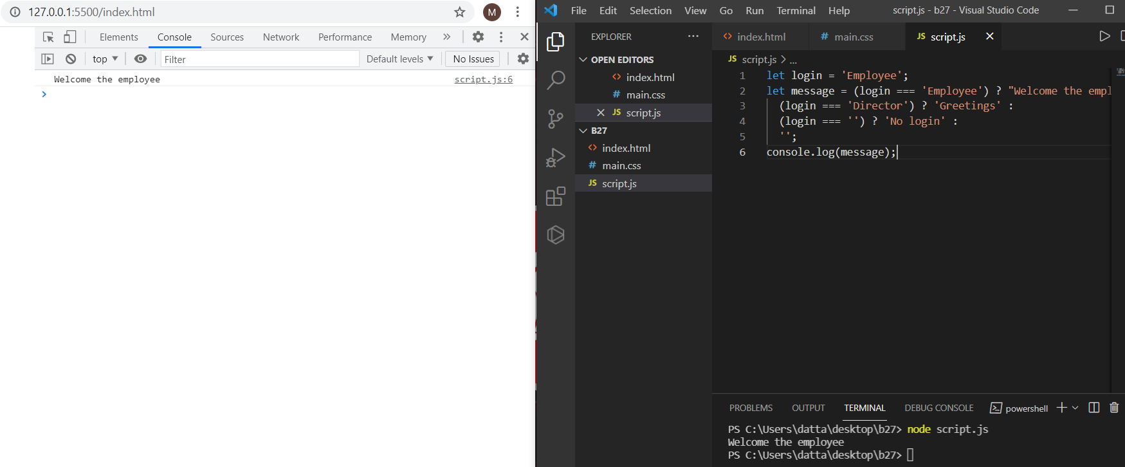

12. **Fix the code to welcome the boss**

**solution:**

**fix.html**

<!DOCTYPE html>

<html>

<body>

<script src="script.js"></script>

</body>

</html>

**Script.js:**

**// You cant change the value of the msg**

**let message;**

**if (null || 2 || undefined )**

**{**

**message = "welcome boss";**

**}**

**else**

**{**

**message = "Go away";**

**}**

**console.log(message);**

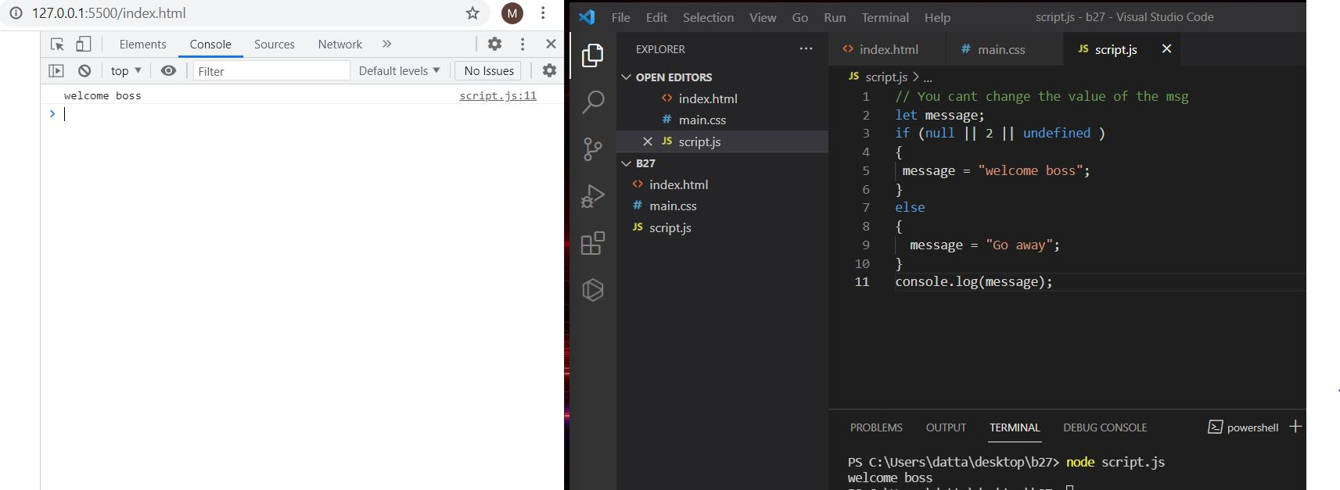

**13. Fix the code to welcome the boss**

**solution:**

**fix.html**

<!DOCTYPE html>

<html>

<body>

<script src="script.js"></script>

</body>

</html>

Script.js:

let message;

let lock;

//Dont change any code below this

if (null || lock || undefined )

{

message = "Go away";

}

else

{

message = "welcome";

}

console.log(message);

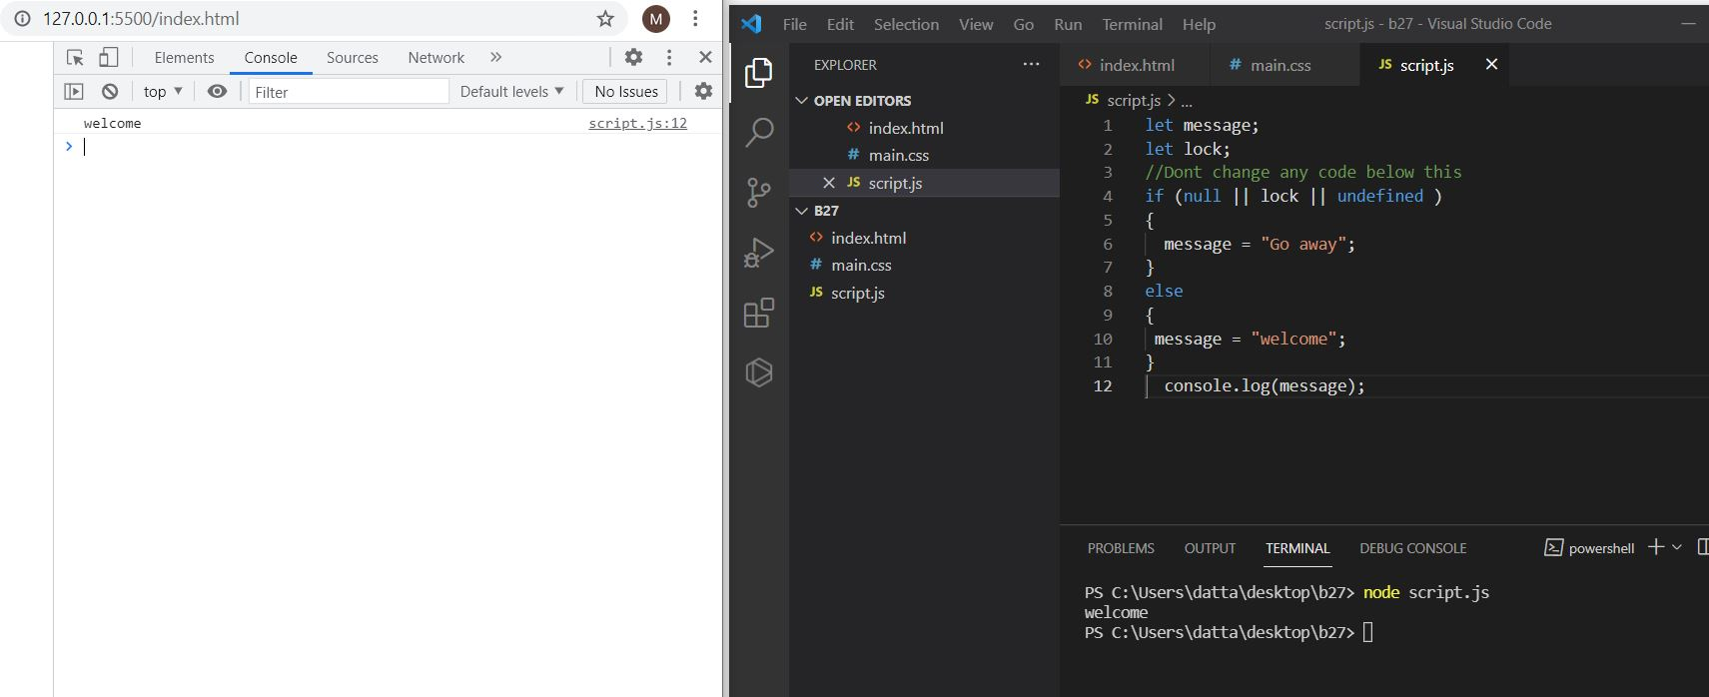

**14. 13. Fix the code to welcome the boss**

**solution:**

**fix.html**

<!DOCTYPE html>

<html>

<body>

<script src="script.js"></script>

</body>

</html>

**Script.js:**

let message;

let lock ;

//Don't change any code below this

if (lock && " " || undefined )

{

message = "Go away";

}

else

{

message = "welcome";

}

console.log(message);

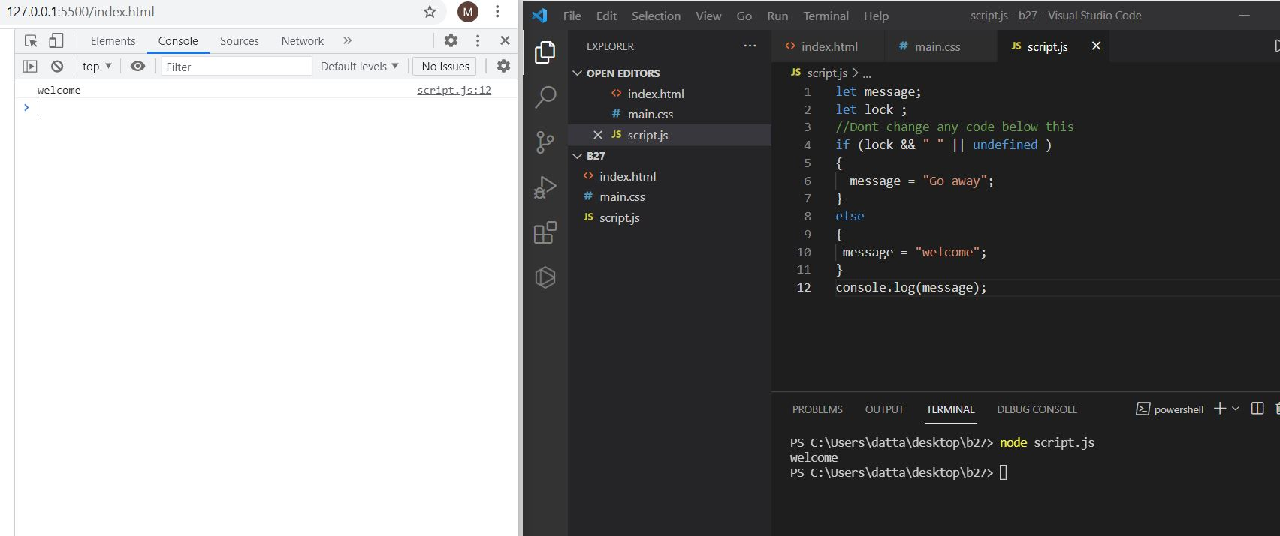

**15. Change the code to print**

**3**

**2**

**1**

**solution:**

**fix.html**

<!DOCTYPE html>

<html>

<body>

<script src="script.js"></script>

</body>

</html>

**Script.js:**

//You can change only 2 characters

let i = 3;

while (i) {

console.log( i );

--i;

}

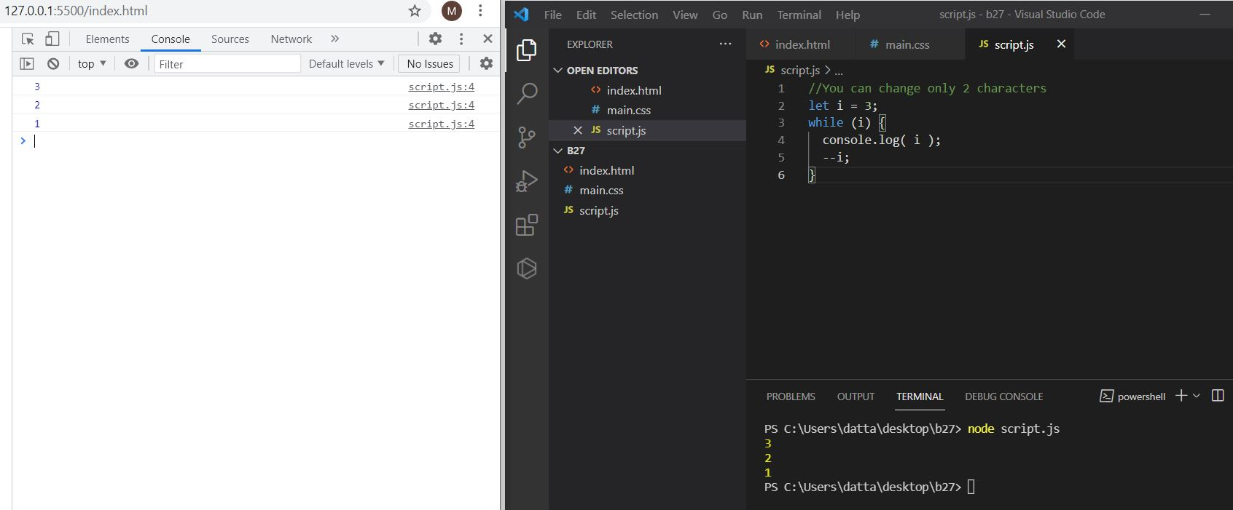

16. **Change the code to print 1 to 10 in 4 lines**

**solution:**

**fix.html**

<!DOCTYPE html>

<html>

<body>

<script src="script.js"></script>

</body>

</html>

**Script.js:**

let num=3;

let newnum ="";

for(i=1;i<=num;i++){

newnum+=i+" ";

}

console.log(newnum);

let num1=5;

let newnum1 ="";

for(i=4;i<=num1;i++){

newnum1+=i+" ";

}

console.log(newnum1);

let num2=8;

let newnum2 ="";

for(i=6;i<=num2;i++){

newnum2+=i+" ";

}

console.log(newnum2);

let num3=10;

let newnum3 ="";

for(i=9;i<=num3;i++){

newnum3+=i+" ";

}

console.log(newnum3);

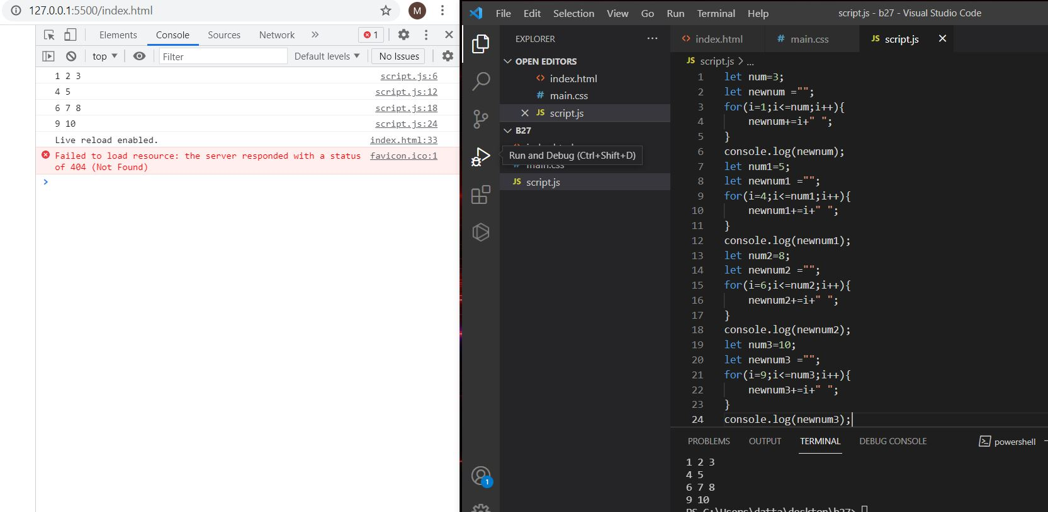

**17. Change the code to print even numbers**

**solution:**

**fix.html**

<!DOCTYPE html>

<html>

<body>

<script src="script.js"></script>

</body>

</html>

**Script.js:**

//You are allowed to modify only one character

for (let num = 2; num <= 20; num += 1) {

if(num%2 === 0)

console.log(num);

}

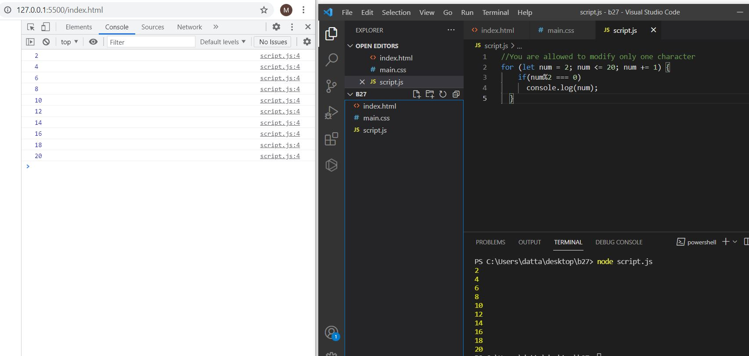

**18. Change the code to print all the gifts**

**solution:**

**fix.html**

<!DOCTYPE html>

<html>

<body>

<script src="script.js"></script>

</body>

</html>

**Script.js:**

let gifts = ["teddy bear", "drone", "doll"];

for (let i = 0; i < 3; i++) {

console.log(`Wrapped ${gifts[i]} and added a bow!`);

}

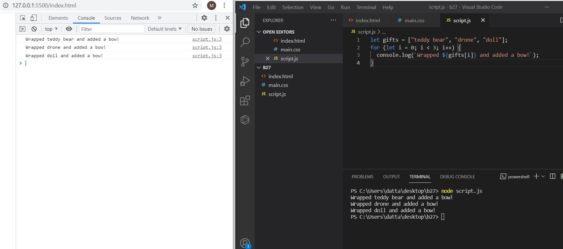

**19. Fix the code to disarm the bomb.**

**solution:**

**fix.html**

<!DOCTYPE html>

<html>

<body>

<script src="script.js"></script>

</body>

</html>

**Script.js:**

let countdown = 100;

while (countdown > 0) {

//countdown--;

if(countdown === 0)

{

console.log("bomb triggered");

}

countdown--;

}

console.log("disarm the bomb");

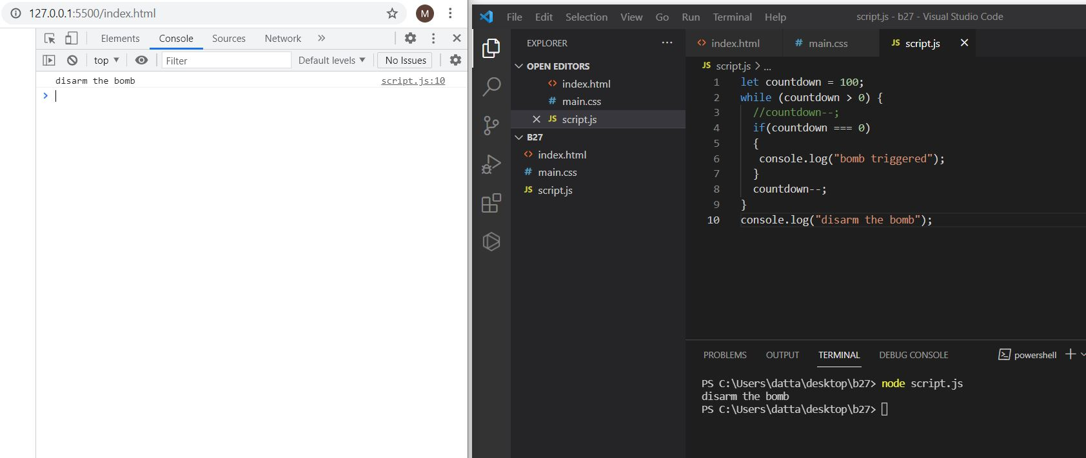

**20,21. Whats the msg printed and why?**

**Solution:** In this the hi message will printed because in the first if condition we have the condition is ok so will print that console output message.

**fix.html**

<!DOCTYPE html>

<html>

<body>

<script src="script.js"></script>

</body>

</html>

**Script.js:**

var lemein = "0";

var lemeout = 0;

var msg = "";

if (lemein) {

msg += "hi";

}

if (lemeout) {

msg += 'Hello';

}

console.log(msg);

